ItemDesignerPanel is a control to design display content of ListBoxItem,
Drag a ListBox into form,
And then drag an ItemDesignerPanel into ListBox,
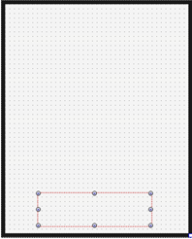
Set the property of ListBox.Properties.ItemDesignPanel as ItemDesignPanel,
It means use ItemDesignPanel to draw content of ListBoxItem,
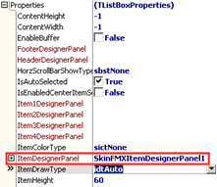
Double click ListBox, add three ListBoxItem in ItemsEditor,
Captions and icons are these:
“Movies”,
“Music”,
“Documents”, ,
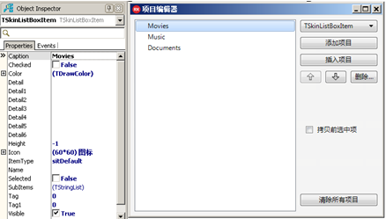
After adding,
ListBox will adjust the height of ItemDesignerPanel with the height of ListItem,
You can use ListBox.Properties.ItemHeight to set ListBoxItem’s height ,
Like this:
Drag a label into ItemDesignPanel,
Set its caption as ”FolderName”,
Set HitTest as False,
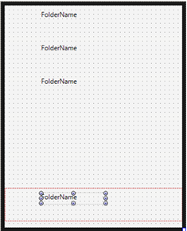
Now we find the three ListBoxItem we added have the same caption ”FolderName”,
We need to make every ListBoxItem to display its own caption,
We need to set ItemCaptionBindingControl of ItemDesignerPanel as this label,
It means use this label to display caption of ListBoxItem,
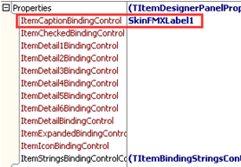
This is the effect,
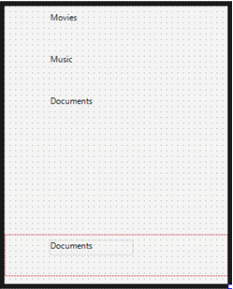
And then drag a ImageControl,
Set size as 40*40,
Set HitTest as False,
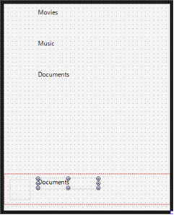
And make this Image to display the icon of ListBoxItem,
We need to set ItemIconBindingControl of ItemDesignerPanel as this Image,
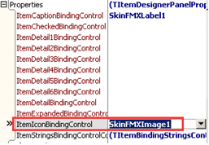
This is the effect:
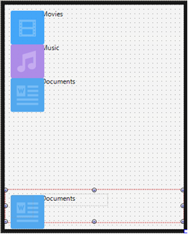
Because the size of this icon is 60*60,
Bigger than the size of Image (40*40) we dragged,
So we need to set SelfOwnMaterial.DrawPictrueParam.IsStretch as True,
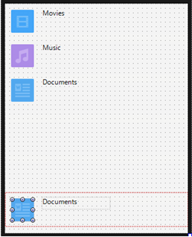
Set the background color of ListBox as white,
Set SelfOwnMaterial.IsTransparent as False,
Set SelfOwnMaterial.BackColor.IsFill as True,
Set SelfOwnMaterial.BackColor.FillColor as white,
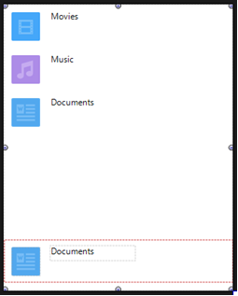
Add split line between every ListBoxItem,
Set SelfOwnMaterial.DrawItemDevideParam.IsFill as True,
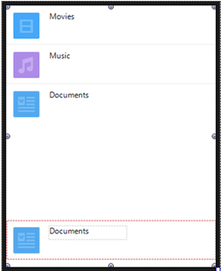
Set the effect of mouse clicking ListBoxItem,
Set ItemDesignerPanel.SelfOwnMaterial.IsTransparent as False,
Unfold ItemDesignerPanel.SelfOwnMaterial.BackColor.MouseDownEffect,
Set EffectTypes as drpetFillColorChange and drpetIsFillChange,
Set FillColor as LightGray,
Set IsFill as True,
It means when mouse clicking, change ListBoxItem ‘s background color .
