ListBoxItem has a property called SubItems,
Its type is TStringList,
You can use SubItems to add innumerable strings,
Such as add three strings ‘aa’, ‘bb’, ‘cc’ .
Drag a ListBox into form,
Then drag a ItemDesignerPanel into ListBox,
Named as idpSubItems,
Set ListBox.Properties.ItemDesignerPanel as idpSubItems,
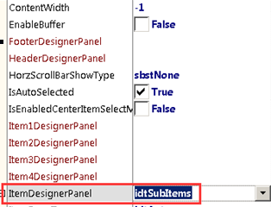
Double click ListBox, add a ListBoxItem,
Double click ListBoxItem’s property SubItems, pop up form StringListEditor,
Input three strings , ‘aa’, ‘bb’, ‘cc’
Then drag three Labels into ItemDesignerPanel,
Named as lblSubItemsIndex1,lblSubItemsIndex2,lblSubItemsIndex3 respectively.
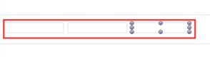
Select ItemDesignerPanel,
Double click its ItemStringBindingControlCollection,
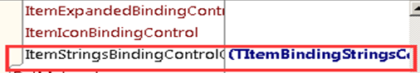
Add three items,
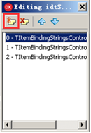
Select the first item,
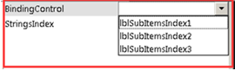
In property editor,
set its property BindingControl as lblSubItemsIndex1, property StringsIndex as 0,
To make it display string ‘aa’, whose index is 0 in SubItems,
Select the second item,
set its property BindingControl as lblSubItemsIndex2, property StringsIndex as 1,
To make it display string ‘bb’, whose index is 1 in SubItems,
Select the third item,
set its property BindingControl as lblSubItemsIndex3, property StringsIndex as 2,
To make it display string ‘cc’, whose index is 2 in SubItems,
Like this :
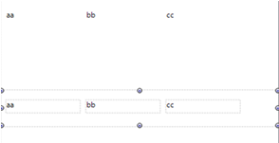
We could add a ListBoxItem again,
Set SubItems as ‘11’, ‘22’, ‘33’,
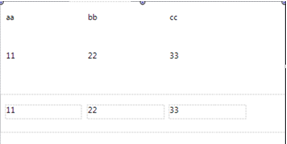
So ,we can fill multiple data into SubIItems,
And then bind multiple Labels in ItemDesignerPanel to display in ListBox.

