Sometimes, NotifyNumberIcon doesn’t need to display NotofyNumber,

It only need to display an icon to notify new message,

Like this unread mark in the list below,



If news ListItem displays this mark,means this news is unread,

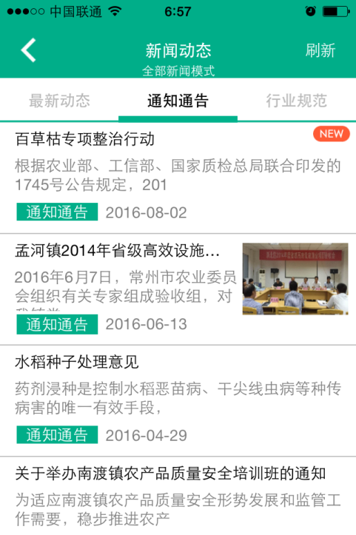

Drag a NotifyNumberIcon into form,

Set size as 35\*18,

Set Properties.Icon as ,



Set Properties.ShowType as nnistIcon,

Means display notification by icon,

,

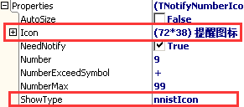

Then set drawparameter of NotifyIcon,

Set DrawIconParam.IsAutoFit as True,

Let’s effect:



Set Properties.NeedNotify as False,

Look at effect:



Display nothing.