In this introduction, I will introduce how to use control PullLoadPanel in OrangrUI, it is used for indicating while loading,

It is common to see PullLoadPanel in ListBox,

For example when you need to refresh data, pull down the content of ListBox until top over, the top will display a rolling circle picture, meaning refreshing

Like this:



Pull up the content of ListBox until bottom over , the bottom will display the loading text, meaning loading more data.

Like this:

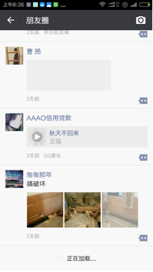

Use PullLoadPanel with ListBox’s ScrollBar,

There are MinPullLoadPanel and MaxPullLoadPanel in VertScrollBar of ListBox ,

MaxPullLoadPanel is the PullLoadPanel of pull down refreshing,

MinPullLoadPanel is the PullLoadPanel of pull up loading,

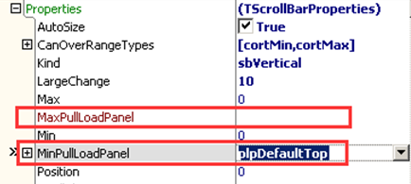

When the content of ListBox diaplays is top over, continue pull down, the blank area comes up,

The MinPullLoadPanel of VertScrollBar begins to display,

When the content of ListBox diaplays is bottom over, continue pull up, the blank area comes up,

The MaxPullLoadPanel of VertScrollBar begins to display,

You can put any control on PullLoadPanel,

But usually put these controls:

Prompt picture, used for displaying whether can load (Image control),

Picture, used for displaying refreshing picture (Image control),

Text, used for displaying present state (Label control),

Text, used for displaying other refreshing information(Label control),

So, properties of PullLoadPanel are:

LoadingImage: image control of displaying loading



LoadingLabel: text control of displaying loading



DecideLoadHintImage: prompt picture control of displaying loading state



LastLoadingInfoLabel: text control of displaying previous loaded information, time or other information



Like this:

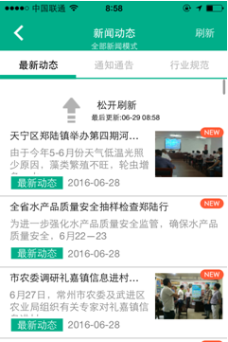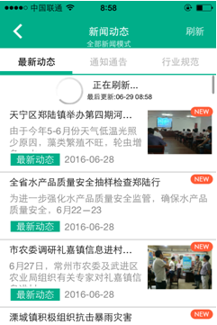

PullLoadPanel has three styles:

When ComponentTypeName is Default,

Is the simplest situation, with only one picture of rolling while loading ,

Properties of material are:

EnableAutoCenterPosition: enable display control automatically centered(when loading picture, display automatically centered)

EnableLoadingImageBiggerEffect:enable enlarge effect of LoadingImage when pulling down

EnableLoadingImageRotateEffect:Enable rotate effect of LoadingImage,

LoadingImageStopBiggerPosition: when pulling down or pulling up ,position of LoadingImage stopping enlarging (0 means default)

LoadingImageBeginRotatePosition: position of LoadingImage start rotasting when pulling down or pulling up (0 means default)

When ComponentTypeName is DefaultEx (a picture and a text)

Compare with style Default,

The material has more properties like these:

DecideLoadCaption: displayed text in position where it can load data as soon as you loosen fingers while dragging(such as “loosen refresh”)

LoadingCaption: displayed text when loading (such as “loading”)

UnDecideLoadCaption: displayed text when knowing unloadable (such as “pull-down refresh”)

LoadingStopCaption: displayed text when load over (such as “successfully refreshed”)