Next introduce the basic functions of PullLoadPanel,
The simplest PullLoadPanel only need to set a Image rolled display when loading data,
These are steps:
Put a ListBox into form,
Drag a PullLoadPanel into ListBox,
Drag an Image into PullLoadPanel,
Set picture as ,
Like this:
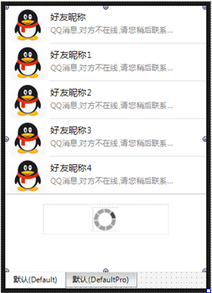
Set PullLoadPanel.Properties.LoadingImage as this Image,
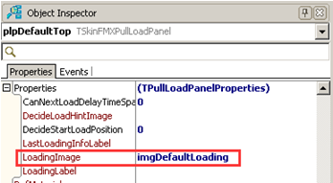
Then Set ListBox.VertScrollBar.Properties.MinPullLoadPanel as this PullLoadPanel,
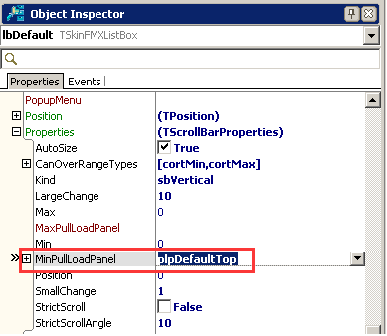
The setting is over.

Next, write codes of loading data in event OnExecuteLoad of PullLoadPanel,
Start a thread to simulate the procedure of loading data,
And call method StopLoad to hide PullLoadPanel after the thread finished,

Why do we need a thread to do load?
If we directly get data from internet in OnExecuteLoad, or do database query,
The UI will block, until the data is got over or the query is done.
Because OnExecuteLoad is executed in main thread, the main thread is used for refreshing and UI interaction,
So, we need to start a thread, load data in thread, and after finishing the thread,
Add data into ListBox,
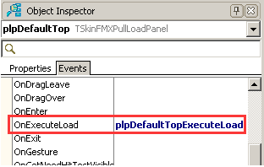
These are code to start thread,
Quote unit uTimerTask,
procedure TFramePullLoadPanel.plpDefaultTopExecuteLoad(Sender: TObject);
var
ATimerTask:TTimerTask;
begin
ATimerTask:=TTimerTask.Create(0);
ATimerTask.OnExecute:=DoThreadExecuteLoad;
ATimerTask.OnExecuteEnd:=DoThreadExecuteLoadEnd;
GetGlobalTimerThread.RunTask(ATimerTask);
end;

procedure TFramePullLoadPanel.DoThreadExecuteLoad(Sender: TObject);
begin
//Simulate thread load data
Sleep(4000);
end;

procedure TFramePullLoadPanel.DoThreadExecuteLoadEnd(Sender: TObject);
begin
//Stop loading
Self.plpDefaultTop.Properties.StopLoad;
end;

Procedure DoThreadExecuteLoad is the procedure of thread loading, it is used for get data list etc,

Procedure DoThreadExecuteLoadEnd is the procedure of thread loading finish, it is used to fill ListBox with data list and stop loading.

Besides, PullLoadPanel also built-in thread loading event( needn’t to set OnExecuteLoad)
Event OnThreadExecuteLoad is the event of loading data list in thread, be careful, don’t interact it with UI,
Event OnThreadLoadFinished is the event of thread loading finish, it can interact with UI.

