Let us make a three-states button to show basic settings of button
Three-states button is a button with three states: normal state, hover state , click state
We use three different pictures to judge which state the button is in
For example, here are three pictures:
: background picture of normal state
:background picture of hover state
:background picture of click state

Set the three pictures respectively to properties NormalPicture、HoverPicture、DownPicture of button SelfOwnMaterial(you can open picture editor by double click NormalPicture )
Then set the button’s caption as “确定”,
Like this:
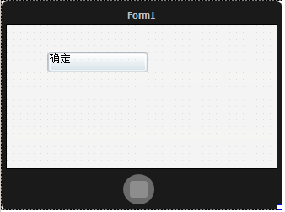
In the above picture, the caption is on left top corner,
We need to put button’s caption in middle position ,
Unfold DrawCaptionParam in SelfOwnMaterial (draw parameters of button caption),
There are two parameters:
Set FontHorzAlign(parameters of horizontally align) as fhaCenter(horizontally center)
Set FontVertAlign (parameters of vertically align) as fvaCenter (vertically center)
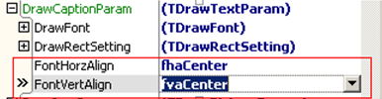
Like this:
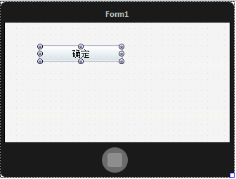
There is one more problem we need to solve:
When the control is stretched bigger, the edge of background picture will get blurs,
Like this(when you stretch the button too big):
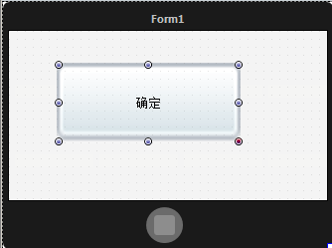
Unfold DrawPictureParam(draw parameters of background picture) in SelfOwnMaterial ,
Set StretchStyle as issSquare
s
Rules of issSquare:
Four corners of background picture will keep the same,
Two horizontal edges will stretch horizontally,
Two vertical edges will stretch vertically,
The middle square will be magnified,
Like this:

When you set up, you needn’t to worry about magnify,
Like this:
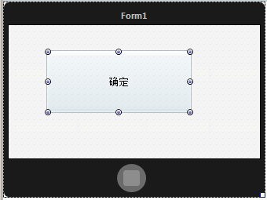
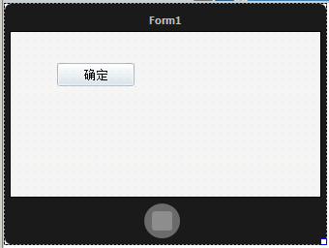
Next run it on platform Windows to see effect:
Normal state:
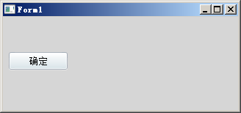
Hover state:
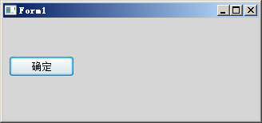
Click state:
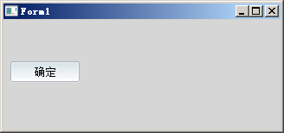
You can make the button has dynamic effects by these steps,
Which is too say , when you click mouse the caption will move 1px to right and down,
Unfold SelfOwnMaterial->DrawCaptionParam->MouseDownEffect(effect when mouse click),
Check dpcetOffsetChange, it means move effect of caption’s position when you click mouse,
Set Offset as 1, means caption position moves 1px,
Set like this:
