These are two states of button,to show if the internet is on.
First prepare the necessary icons:
: means network disconnected,
:means network connected.
Drag a button in form, set width and height both as 44,
Set Icon as the first icon above,
Set PushedIcon as the second icon above.
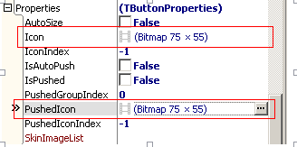
when you set up ,you will find,the size of button is 44*44,but the size of icon is 75*75,obviously it is too big to show the whole.
like this:
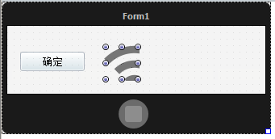

You need to set the DrawIconParam,
Set IsAutoFit as true,
it means when you are drawing icon,the icon will adjust its size automatically to the control .and the scale of icon won’t be distorted..
Set PictureHorzAlign as phaCenter,means center horizontal,
Set PictureVertAlign as pvaCenter,means vertical horizontal
Like this,
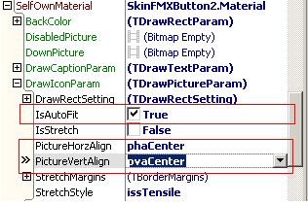
Here is the effect of display:
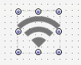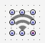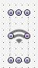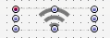
If you set IsAutoFit of DrawIconParam as False,
The scale of icon will be distorted while you stretching the button.
Like this:
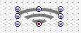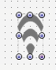

So how can you switch the button to the state of network connected?
You need to set button as pressed state(set IsPushed as True ),
Like this:
