The effect of ButtonGroup is like this:
Drag three buttons into form,
Set all buttons’ size as 77*28,
Prepare six pictures as background,
Every button needs two pictures,
One as background picture of normal state,
Another as background picture of pressed state,
Here are the necessary materials:
The first button:
The second button:
The third button:
Set NormalPicture of three buttons respectively as the first picture above,
Set PushedPicture of three buttons as the second picture above,
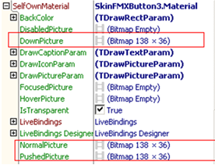
When you set up you can see this:
Set captions of three buttons respectively:
Set caption as center display (FontHortAlign as fhaCenter ,FontVertAlign as fvaCenter)
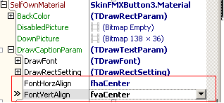
Align three buttons horizontally and closely
Like this:
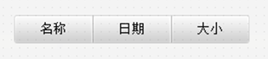
While running , you will find click one of these buttons,
The button won’t become pressed state automatically,
You need to set property IsAutoPush,
And then when you click, the button will automatically become pressed state,
Then click two of these buttons,
You will find two buttons become pressed state at the same time,
Like this,
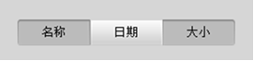
That’s because you haven’t set the three buttons as a group,
Their PushedGroupIndex is 0,
Like this:
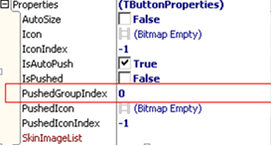
How could we set them as a group?
We need to set the three buttons’ PushedGroupIndex as 1(any number except 0 will be ok)
Now ,when you click one of these buttons, set it as pressed state(IsPushed=True),
The other two buttons will automatically set as unpressed state(IsPushed=False ),
Like this,

