FrameImage inherits from Image,
It can set one more picture on the basic of Image,
This picture covers on Image.Properties.Picture,
It can be used to make the effect of photo frame

Next, let’s show,
How to add round corner photo frame to this avatar picture,
Avatar picture:
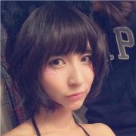
Round corner photo frame picture:
Drag a FrameImage into form,
Set size as 100*100,
Double click Properties.Picture,
Select the avatar picture above in the popped up select picture Dialog Box,
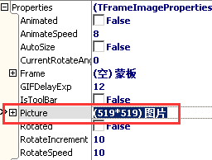
Then set picture’s draw parameter,
Set DrawPictureParam.IsAutoFit as True,
Set DrawPictureParam.IsStretch as True,
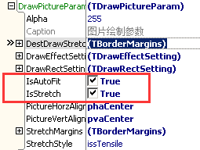
Like this:
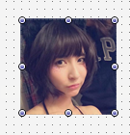
Next we set Properties.Frame，
Double click Properties.Frame，
Select the round corner photo frame picture above in the popped up select picture DialogBox,
Ok, this is the effect:
