Drag a label control into form
Set the caption of label
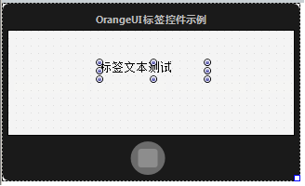
In property DrawCaptionParam.DrawFont you can set caption’s font,
You can set font’s size, color, style and align etc.
Like this:
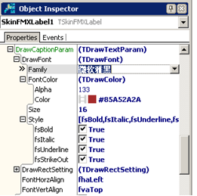
Here is the effect:
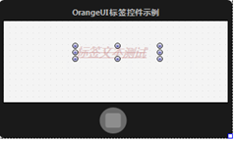
FontHorzAlign means set font as horizontally align
Align left:
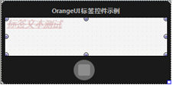
Align right:
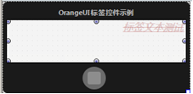
FontVertAlign means set font as vertically align
Align top:
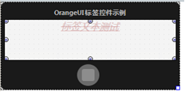
Align bottom:
