Drag a MultiColorLabel into form,
Double click its property ColorTextCollection,
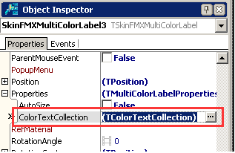
Click AddButton to add two TColorTextItems,
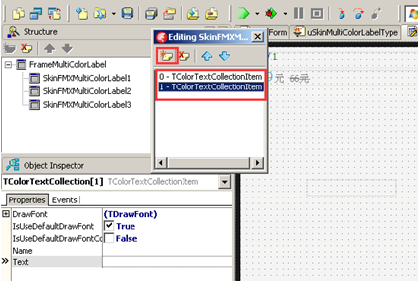
These are TColorTextItem’s properties:
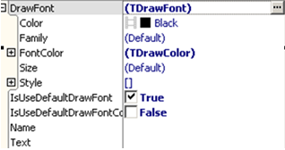
Set the first ColorTextItem’s Text as ‘499’, means the integer part of price,
Set the second ColorTextItem’s Text as ‘00’, means the fraction part of price,
Like this:
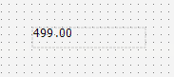
And set the first ColorTextItem’s FontColor as Blue,
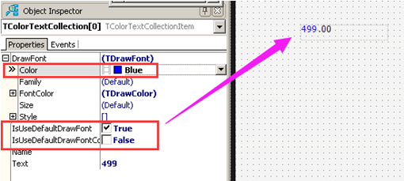
So the number ‘499’ becomes blue,
We still need to enlarge ‘499’ s font,
We need to uncheck IsUseDefaultDrawFont,
Means not use default font,
Then set DrawFont.Size as 20,
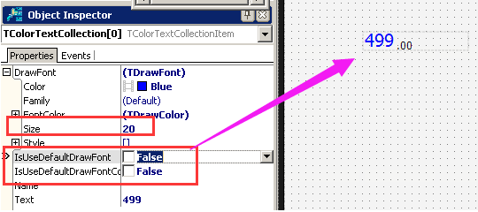
Set the second ColorTextItem’s FontColor as Red,
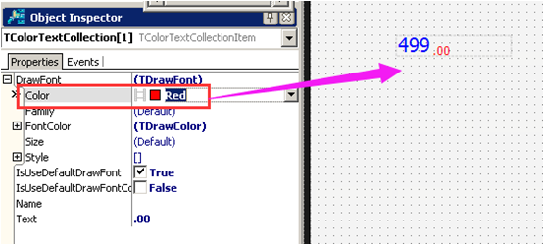
This is the final effect,
