In this example we will introduce how to use MultiColorLabel to bind property of ListBoxItem,
Drag a MultiColorLabel into ItemDesignerPanel,
Double click ListBox,
Add a ListBoxItem in the popped up ListItem Editor,
Set its caption as “2”,
Set Detail as“3”,
Set Detail1 as“4”,
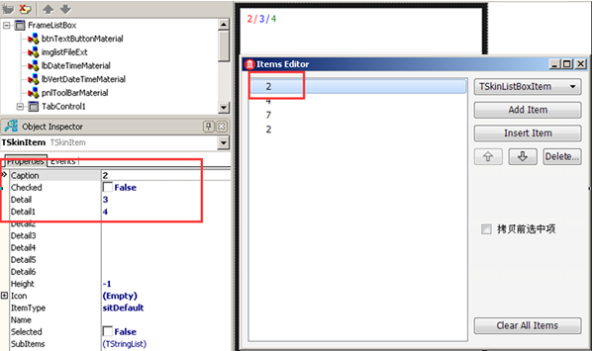
Set ColorTextCollection of this MultiColorLabel,
Double click ColorTextCollection of MultiColorLabel,
Add a ColorTextCollectionItem,
Set DrawFont.Color as Red,
Set name as ‘ItemCaption’,
Means bind Caption of ListBoxItem,
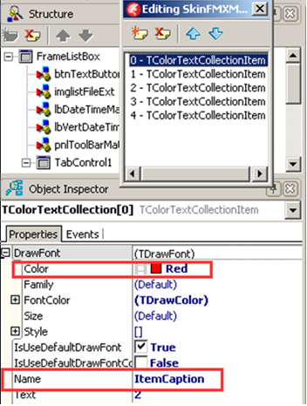
Finally ,
Set ItemCaptionBindingControl of ItemDesignerPanel as this MultiColorLabel,
Means make ColorTextCollectionItem whose name is ”ItemCaption” in MultiColorLabel display caption of lIstItem,
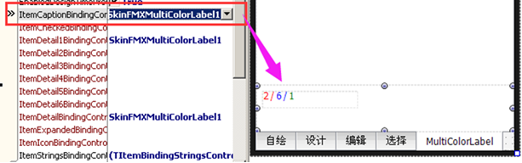
In the same way, we can new multiple ColorTextCollectionItem,
Set their names as ItemDetail,ItemDetail1,ItemDetail2,……
To bind ListBoxItem’s other properties with MultiColorLabel.

