New a project,
The shown and hidden events got by virtual keyboard of FireMonkey in class TForm.
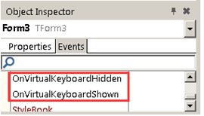
Event OnVirtualKeyboardHidden is the event of virtual keyboard hidden,
Event OnVirtualKeyboardShown is the event of virtual keyboard Shown,
This is the declaration of these two events
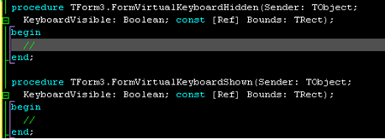
KeyboardVisible:Boolean means the keyboard is visible or invisible
Bounds:Rect means the area of keyboard

Put an Edit on the position near bottom in form,
So when the virtual keyboard show can cover it
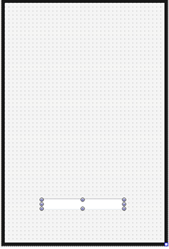
Run it in IOS simulator to see effect
Click Edit, show virtual keyboard,
Call OnVirtualKeyboardShown,
The parameters of Bounds are (0,220,320,480),
480-220=260, it means the height of virtual keyboard is 260,
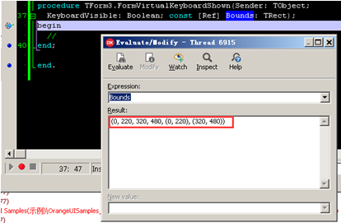
And we can’t see Edit, because it is covered by virtual keyboard.
We can’t know what we have input,
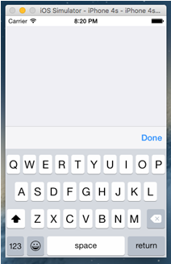
Usually the solution is:
Put Edit in ScrollBox,
And put a Panel on the bottom of form,
When showing virtual keyboard,
Set the height of panel as same as the height of virtual keyboard,
Set the Position of ScrollBox rationally,
So we can move Edit above virtual keyboard.

These are steps:
Put a ScrollBox on form, named as sbClient,
Set Align as Client,
And put a ScrollBoxContent in ScrollBox , named as sbClient,
Don’t set its Align,
Drag sbcClient to the top of ScrollBox,
Extend sbcClient to some width,
Put a Panel on Form,
Named as pnlVirtualKeyboard, set Align as Bottom,
Set its background color as black temporarily,
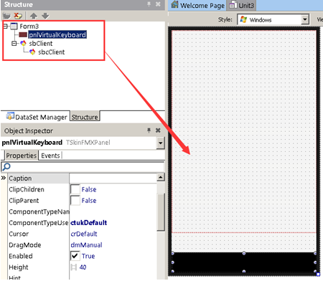
Because at original state the virtual keyboard isn’t shown,
Set the height of Panel as 0.

Put an Edit on sbcClient,
Set background color as orange,
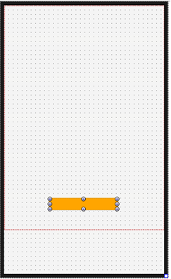
In the event of virtual keyboard, panel’s height as virtual keyboard’s height
The propose of put a Panel on bottom is,
When virtual keyboard showing,
Set the panel’s height as virtual keyboard’s height
When virtual keyboard hides,
Set the panel’s height as 0
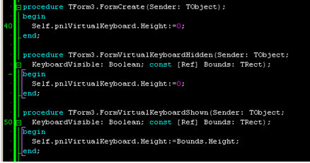
Run it, click Edit, the virtual keyboard will show,
But it still covers Edit,
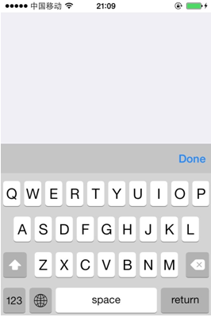
But Edit is put on ScrollBox,
So we can drag ScrollBox by finger,
To move on Edit.
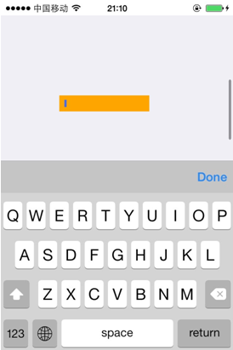
So when the virtual keyboard show, how to set the Position of ScrollBox automatically,
To make Edit roll to visible position?
The height of form is 480,
The height of virtual keyboard is 260,
So the height left to show content is only 220,
But the Top of Edit is 320,
So Edit is covered,
To drag the Position of ScrollBox.VertScrollBar up,
Calculate in event OnVirtualKeyboardShown,
When virtual keyboard shows,
ScrollBox.VertScrollBox.Position is,
Edit.Top-(Form.Height-Keyboard.Height)+Edit.Height,
Actually, (Form.Height-Keyboard.Height) is Keyboard.Top,
So it can be written as:
Edit.Top-Keyboard.Top+Edit.Height,
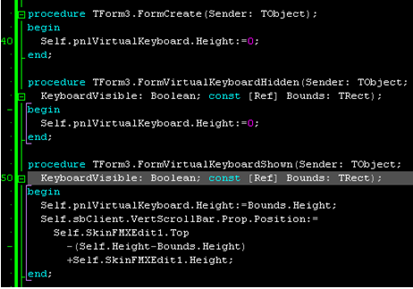
Let’s try,
Original state:
Click Edit, show virtual keyboard,
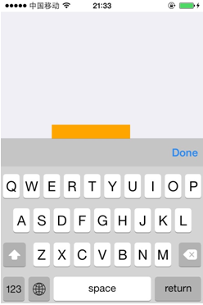
Even we put Edit on the bottom,
It is still ok.

