There are functions and interfaces to deal with virtual keyboard in Frame of uUIFunction.pas
The file is in OrangeUI Samples(example)\OrangeProjectCommon directory

New a project,
Add unit uUIFunction.pas into project,Use this unit in MainForm,
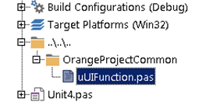
Set virtual keyboard event of MainForm

In virtual keyboard shown event OnVirtualKeyboardShown,
Add procedure to notify Frame virtual keyboard shown event
CallSubFrameVirtualKeyboardShown(Sender,Self,KeyboardVisible,Bounds);

In virtual keyboard hidden event OnVirtualKeyboardHidden:
Add procedure to notify Frame virtual keyboard hidden event
CallSubFrameVirtualKeyboardHidden(Sender,Self,KeyboardVisible,Bounds);

And in event OnShow of MainForm add code to fix virtual keyboard shown and hidden in Android: GetGlobalVirtualKeyboardFixer.StartSync(Self);
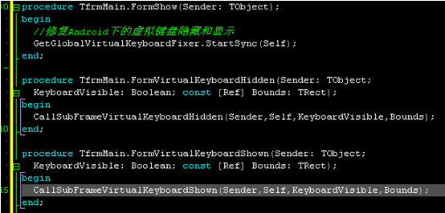

New a Frame, Name is FrameLogin, unit name is LoginFrame.pas,
We use it as login page,

Put a Panel on Frame, named as pnlVirtualKeyboard,
Set Align as Bottom,
Put ScrollBox , named as sbClient, set Align as Client,
Put ScrollBoxContent on ScrollBox, named as sbcClient,

Put Edit for user id and passport on sbcClient,
Like this:
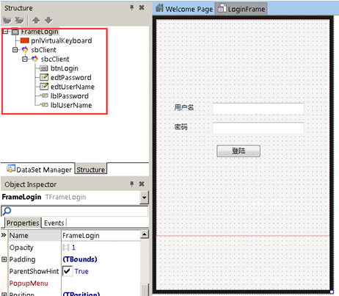
If Frame wants to respond to the event virtual keyboard shown and hidden,
We need to realize interface IFrameVirtualKeyboardEvent that we defined in unit uUIFunction.pas

IFrameVirtualKeyboardEvent=interface
['{3EA28E86-BEC2-432A-A744-C5210B0D3B85}']
//display virtual keyboard
procedure DoVirtualKeyboardShow(KeyboardVisible: Boolean; const Bounds: TRect);
//hide virtual keyboard
procedure DoVirtualKeyboardHide(KeyboardVisible: Boolean; const Bounds: TRect);
end;
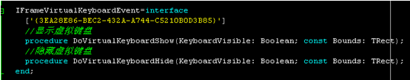
Use unit uUIFunction in LoginFrame.pas,
Add IFrameVirtualKeyboardEvent in declaration of FrameLogin,
And add two methods of connector:
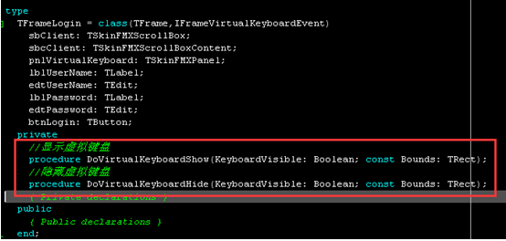
Realize these methods:
When virtual keyboard hides, set the height of pnlVirtualKeyboard as 0,
When virtual keyboard displays ,set the height of pnlVirtualKeyboard as same as virtual keyboard’s.
So, the sroll area of ScrollBox is on virtual keyboard, won’t be covered.
Set the position of ScrollBox.VertScrollBar to display login button.
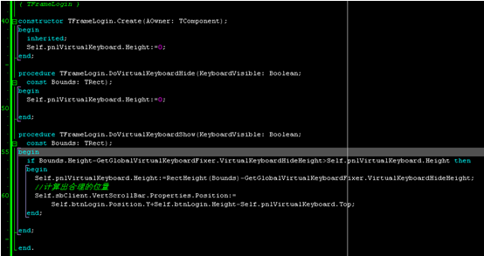
In the event of FormShow, dynamically create LoginFrame to display login page
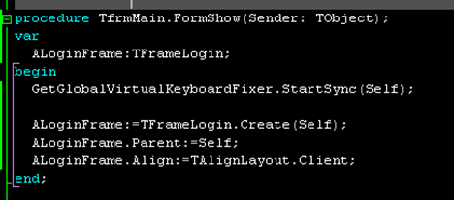
var
ALoginFrame:TFrameLogin;
begin
ALoginFrame:=TFrameLogin.Create(Self);
ALoginFrame.Parent:=Self;
ALoginFrame.Align:=TAlignLayout.Client;

