New a project.
Add unit uUIFunction.pas into project, use this unit in MainForm,

Use unit uComponentType of OrangeUI in MainForm
Put a Panel on MainForm to simulate VirtualKeyboard show,
When VirtualKeyboard show, it will set Panel’s height as VirtualKeyboard’s height.
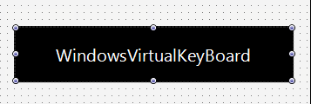
Then set VirtualKeyboard event of MainForm,

In virtual keyboard shown event OnVirtualKeyboardShown,
Add procedure to notify Frame virtual keyboard shown event
CallSubFrameVirtualKeyboardShown(Sender,Self,KeyboardVisible,Bounds);

In virtual keyboard hidden event OnVirtualKeyboardHidden:
Add procedure to notify Frame virtual keyboard hidden event
CallSubFrameVirtualKeyboardHidden(Sender,Self,KeyboardVisible,Bounds);

And in event OnShow of MainForm add these:
Codes of enabling simulate VirtualKeyboard and assign VirtualKeyboard simulate control,
Codes of fixing VirtualKeyboard in Android,
Codes of dealing with VirtualKeyboard shown and hidden,
Like this:
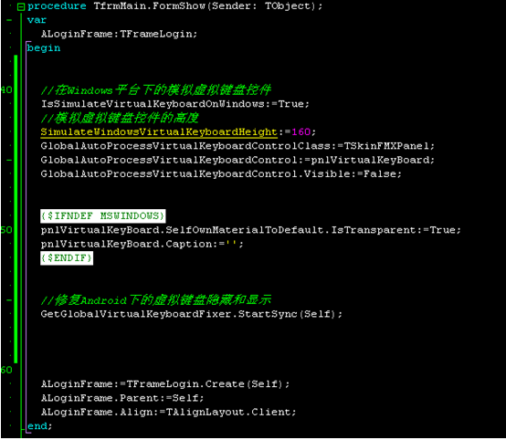
// VirtualKeyboard control on platform Windows
IsSimulateVirtualKeyboardOnWindows:=True;
// height of simulating VirtualKeyboard
SimulateWindowsVirtualKeyboardHeight:=160;
GlobalAutoProcessVirtualKeyboardControlClass:=TSkinFMXPanel;
GlobalAutoProcessVirtualKeyboardControl:=pnlVirtualKeyBoard;
GlobalAutoProcessVirtualKeyboardControl.Visible:=False;

{$IFNDEF MSWINDOWS}
// set as transparent in simulator
pnlVirtualKeyBoard.SelfOwnMaterialToDefault.IsTransparent:=True;
pnlVirtualKeyBoard.Caption:='';
{$ENDIF}

// fix VirtualKeyboard shown and hidden in Android
GetGlobalVirtualKeyboardFixer.StartSync(Self);
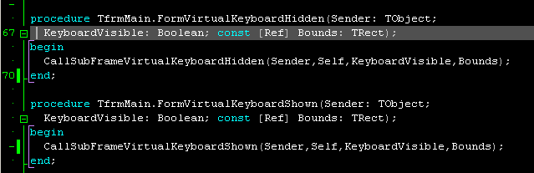
New a Frame, Name is FrameLogin, unit name is LoginFrame.pas,
We use it as login page,

Put ScrollBox , named as sbClient, set Align as Client,
Put ScrollBoxContent on ScrollBox, named as sbcClient,

Put controls for user name and password on sbcClient,
Type of edtPassword and edtUserName must be TSkinFMXEdit,
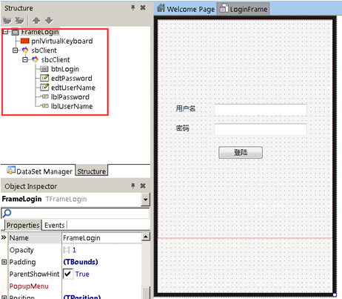
If you want to realize the interface IFrameVirtualKeyboardEvent defined in unit uUIFunction.pas,

IFrameVirtualKeyboardAutoProcessEvent=interface
['{D25150F4-EB4C-4097-93FE-51BFD19FF29D}']
//control need to be processed currently
function GetCurrentPorcessControl(AFocusedControl:TControl):TControl;
//where to put VirtualKeyboard
function GetVirtualKeyboardControlParent:TControl;
end;
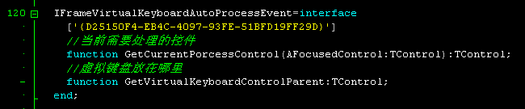
Use unit uUIFunction in uses of LoginFrame.pas,
Add IFrameVirtualKeyboardAutoProcessEvent declaration of FrameLogin,
Add two methods of interface, realize them,
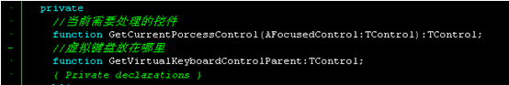
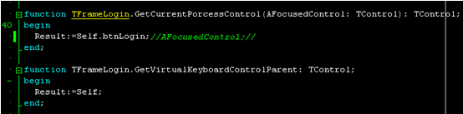
In the event FormShow of form dynamically create LoginFrame to display login page,
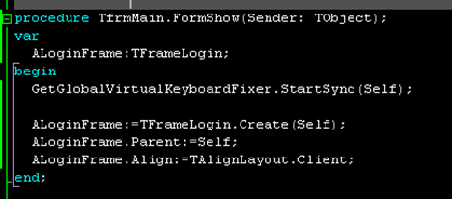
var
ALoginFrame:TFrameLogin;
begin
ALoginFrame:=TFrameLogin.Create(Self);
ALoginFrame.Parent:=Self;
ALoginFrame.Align:=TAlignLayout.Client;

You can click SkinFMXEdit on platform Windows to simulate effect of VirtualKeyboard displaying,
