sImageList is used for stores pictures,
It has only one property called PictureList,
If there is no picture in ImageList, then PictureList will show “no picture”,
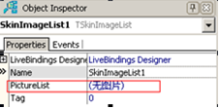
If there are 11 pictures in ImageList, then PictureList will show “11 pictures”.s
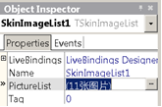
Double click ImageList in form, will pop-up picture list editor,
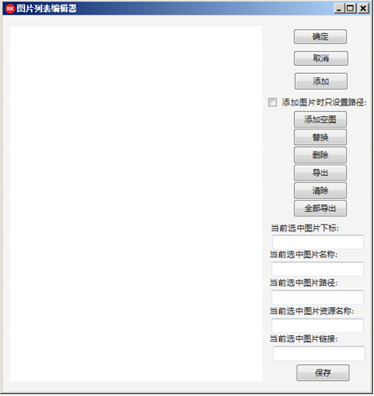
Click add, you can add pictures into list,
