Double click property Picture,
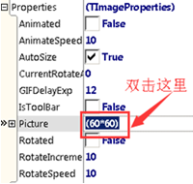
The picture editor will come up, choose one picture,
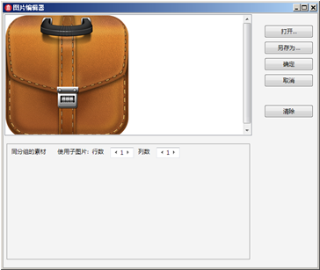
Click ok ,you can see effect,
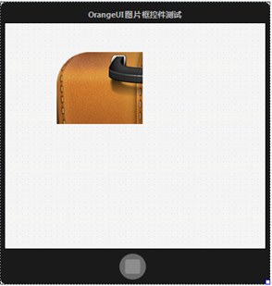
You can’t see whole picture, that’s because the size of picture is 256*256,
But the size of control is 120*100,
If you want to display whole picture,
Set SelfOwnMaterial.IsStretch as True,
StretchStyle as issTensile,
It means stretch picture to fill whole control,
