We can use control Image to play GIF picture,
Double click control’s Picture property,
Choose a GIF picture,
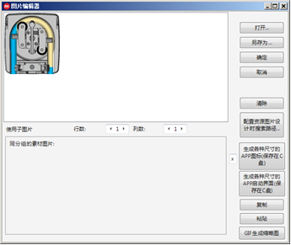
Set property Animated as True,
The GIF picture can be played dynamically,
And you can set play speed in property AnimateSpeed

