ImageControl can display pictures from internet,
Take my blog avatar as an example,
This is the link of avatar: http://avatar.csdn.net/7/9/6/1_delphiteacher.jpg
These are steps to complete it:
Set Properties.Picture.Url
As http://avatar.csdn.net/7/9/6/1_delphiteacher.jpg,
Like this:
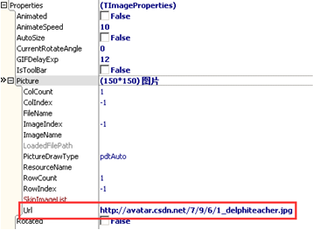
Just a moment, the avatar is displayed,
This is the mechanism of displaying internet picture in OrangeUI,
When we set url for ImageControl,
DownloadPictureManager will start a thread to download pictures from internet in background,
The pictures will be stored in folder OrangeUIDownloadPictures of program directory,
(ps: we need to add uIdHttpControl.pas or uNativeHttpControl.pas in project)

