Explain simple setting of CheckBox,
We need these two pictures:
: checked picture of CheckBox in default state, set to SelfOwnMaterial.NormalCheckedPicture,
: unchecked pictureof CheckBox in default state, set to SelfOwnMaterial.NormalUnCheckedPicture
Set display size of picture,
In SelfOwnMaterial.DrawPictureParam,
Set DrawPictureParam.IsAutoFit as True,
Set DrawPictureParam.DrawRectSetting.Enabled as True,
Set DrawPictureParam.DrawRectSetting.Height as 80,
Set DrawPictureParam.DrawRectSetting.PositionVertType as dppvtCenter,
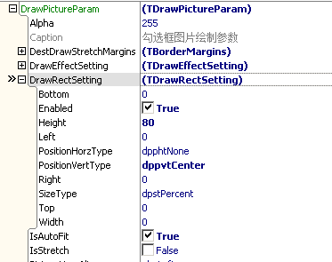
Next set caption’s displaying,
There is a property called IsAutoPosition in SelfOwnMaterial,
It means display caption on right of picture automatically,
So we only need to make caption display vertically centered,
Don’t need to set caption’s left margin.
In SelfOwnMaterial.DrawCaptionParam,
Set DrawCaptionParam.FontVertAlign as fvaCenter,
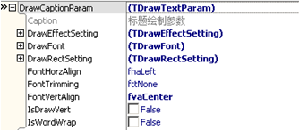
Set over, this is display effect:
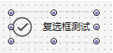
Set Porperties.Checked as True, display like this:
